6.Perform basic Image Handling and processing operations on the image is to read an image in python and Convert an Image to erode using Erode function.

**AIM:**

To read an image and convert it to grayscale using OpenCV in Python.

**PROCEDURE:**

1. Install OpenCV (if not already installed):install opencv-python
2. Import required libraries
3. Read the image
4. Convert the image to grayscale
5. Display the images
6. Wait for a key press & close windows

**PROGRAM:**

import cv2

import numpy as np

image = cv2.imread(r"C:\Users\sr051\OneDrive\Desktop\ITA0504-CV\tree.jpg")

if image is None:

print("Error: Image not found.")

else:

gray = cv2.cvtColor(image, cv2.COLOR_BGR2GRAY)

kernel = np.ones((5, 5), np.uint8)

eroded = cv2.erode(gray, kernel, iterations=1)

cv2.imshow("Original", gray)

cv2.imshow("Eroded", eroded)

cv2.waitKey(0)

cv2.destroyAllWindows()

**INPUT:**

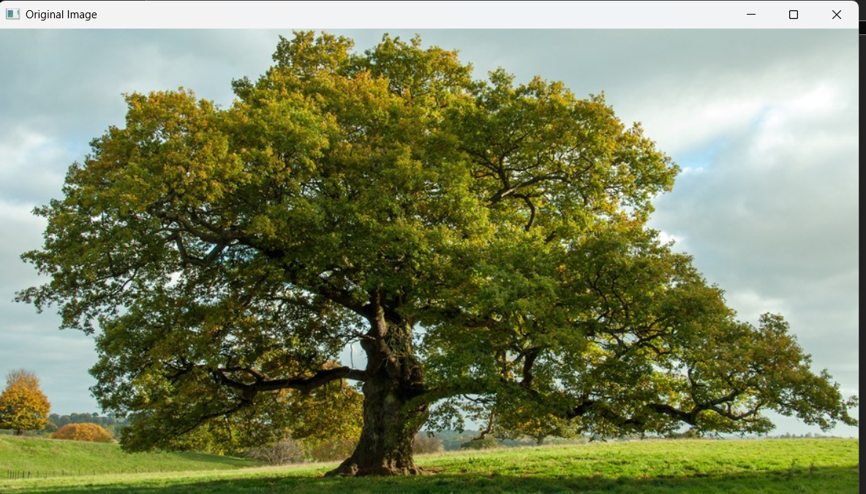

**OUTPUT:**

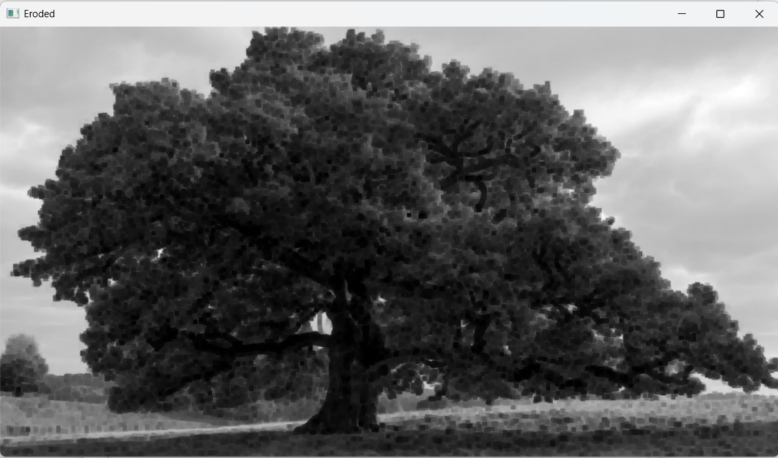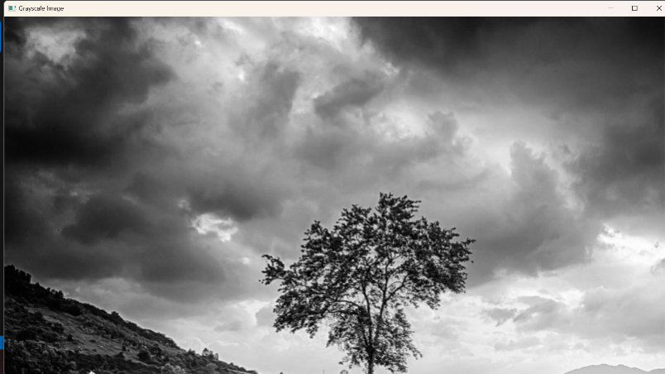

**RESULT :**

Successfully read the input image and converted it to grayscale using OpenCV in Python.